Processor Management Use Case

Submitted to

Alpha Payments Cloud


Tarang Software Technologies Private Limited
Tarang Towers,
#400/2, Whitefield 100 ft road,
Hoody circle,
Bangalore, India
Phone: +91-80-41157777
WEB: www.tarangtech.com

© This document is exclusive property of Tarang software Technologies Private Limited. No part of this may reproduced in any form without written permission.

Document Change History

Ver# | Editor | Date | Reviewer | Approver | Changes made
0.1 | Vikash Ranjan | 4th Sep 2012 | Bindu V |  | Draft version
1.0 | Vikash Ranjan | 10th Sep 2012 | Bindu V |  | Baseline version
1.01 | Vikash Ranjan | 18th Sep 2012 | Ronan |  | Updated with Review comments
1.02 | Vikash Ranjan | 21st Sep 2012 | Ronan |  | Updated the add processor use case, removed channel config use case, enable/Disable processor use case
1.03 | Vikash Ranjan | 28th Sep 2012 | Ronan |  | Updated the Fee and Add/Edit Currency use case

Table of Contents
1 Introduction 4
2 Use Case: add/edit Processors 4
2.1 User Interface Information 5
2.1.1 User Interface details for Add/Edit Processor 5
3 Use Case: Add/Edit CURRENCY FOR Processors 6
3.1 User Interface Information 7
3.1.1 User Interface details 7
4 Use Case: Fee configuration 7
4.1 User Interface Information 9
4.1.1 User Interface details for Fee 9

Introduction

This document describes the use cases for adding new processor, Fee configuration and manage Processor configuration in APC System.

Use Case: add/edit Processors

Title | Processors Add/Edit
Requirement ID | RID-1071
Actors | APC User with appropriate privilege to manage Processor
Description | Allows the Actor to configure Processors in APC
Use case trigger | - Actor selects “Add” from the “Manage Processors” menu in APC.  - Actor selects “Edit” from the “Manage Processors” menu against the corresponding Processor record to edit the details in APC.
Main flow / Flow of Events | - Selection of Add/Edit in 'Manage Processors' will navigate to corresponding screen.  - Details of Input field are as below:  Processor Name  Processor Code  Contact Person  Email Address  Country  Payment Method  Primary URL – Request URL and Response URL  Secondary URL – Request URL and Response URL  Request Mode  Status  - Actor shall enter/edit the relevant information & Click on Save.  - APC System will validate the information entered & save the details in the DB. The respective Processor should get listed as part of the Processors list.
Sub-flow/Alternate Flows/ Scenarios | - If the actor enters the invalid data, the Actor shall be navigated to the same screen with appropriate error message.
Assumptions
Pre-conditions | Actor is logged into the Application with appropriate privilege to manage processor in the APC
Post-conditions | - Add - New Processor will successfully be created in the system.  - Edit – the edited details of the Processor shall get successfully updated in the DB.
Status | Open
Issues | None
Business Rules | Processor Code will be unique and cannot be modified.  Request mode supported by the processor shall be a check box field to select one or more type. The list of type shall be Web, MOTO, Recurring

User Interface Information

User Interface details for Add/Edit Processor
Refer Manage Processor screen of the storyboard
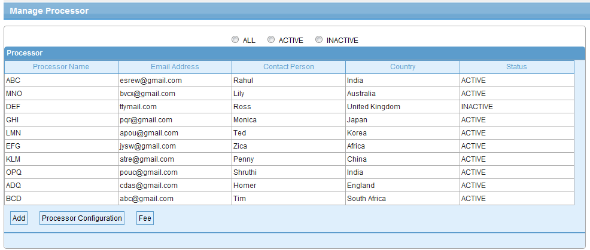

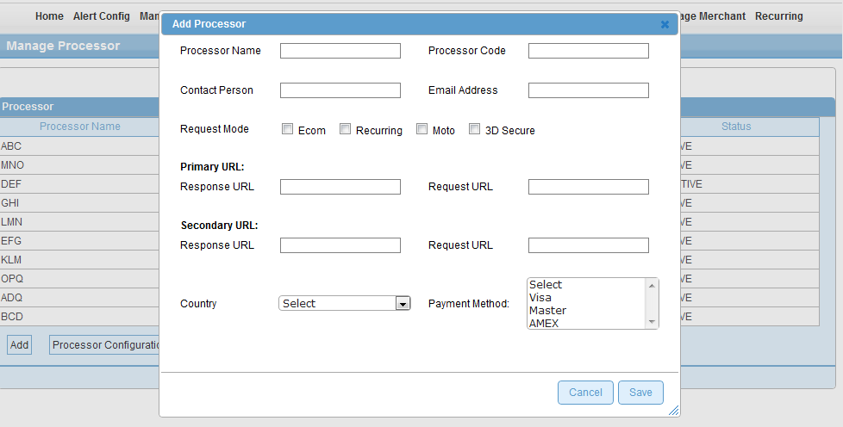

Validations for Add/Edit Processor
Will be updated later

Id | Parameter Name | Field Type | Special characters | Validations | Field Length | Possible Values | Additional Condition | Mandatory
1 | Processor Code | Textbox | No | Alpha | 20 |  |  | Yes
2 | Processor Name | Textbox | No | Alphas | 30 |  |  | yes
3 | Country | Drop down | Na | Na | Na |  |  | No
4 | Contact Person | Textbox | No | Alpha | 35 |  |  | Yes
5 | Email Address | Textbox | Yes | Alphanumeric | 75 | Valid email format |  | Yes
6 | Payment Method | Drop down | No | NA | Na | Multi select | Minimum one value | Yes
7 | Request Mode | Checkbox | No | No | Na | Ecomm,  Moto, Recurring,  3D Secure  POS  IVR |  | Yes
8 | Primary URL – Request URL, Response URL | Text box | Yes | Alphanumeric | 100 | Valid url |  | Yes
9 | Secondary URL – Request URL, Response URL | Text box | Yes | Alphanumeric | 100 | Valid url |  | No
10 | Status | Drop down | No | Na | Na | Active/Inactive | Default = Active

Use Case: Add/Edit CURRENCY FOR Processors
Title | Add/Edit Currency for Payment Methods of Processors
Requirement ID | RID-1072
Actors | APC User with appropriate privilege.
Description | Allows the Actor to configure Currency for Payment Methods supported by Processors, Add the Auth and Settle Currency and currency mapping
Use case trigger | - Actor selects “Processor Configuration” from the “Manage Processors” menu against the corresponding Processor record to configure Currency/ies of Payment Methods  Then chooses to selects 'Add Currency' on Payment Method Configuration screens  With corresponding Payment Methods.  - Actor selects “Processor Configuration” from the “Manage Processors” menu against the corresponding Processor record to configure Currency of Payment Methods  Then chooses to selects 'Edit currency' on Payment Method Configuration screen with  Corresponding Payment Methods.
Main flow / Flow of Events | - System will navigate the actor to the Add/Edit Currency screen along with the currency list to be selected / removed and the list of payment method as check box  - Actor will select the payment method and select/edit the currency(Auth and Settle) list  - Add the currency mapping for the Auth and Settle currency & click on save.  - System associates the currency list with corresponding Payment Methods and save the details in the DB.
Sub-flow/Alternate Flows/ Scenarios | N/A
Assumptions | Currency List is pre defined list
Pre-conditions | Actor is logged into the Application with appropriate permissions.
Post-conditions | - Add Currency – Currency List will be associated to payment Methods for Processors  - Edit Currency– Edited Currency List will be associated to payment Methods for Processors
Status | Open
Issues | None
Business Rules | Associate Currency(Auth and Settle) to Payment methods

User Interface Information

User Interface details

Refer Payment Method screen to add/edit currency

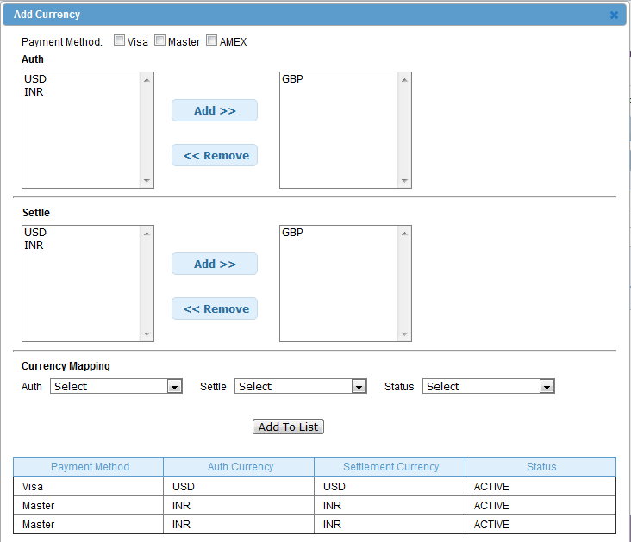

Validations
None

Use Case: Fee configuration

Title | Fee Configuration
Requirement ID | RID-1073
Actors | APC User with appropriate privilege
Description | Fee configuration for a processor in APC System
Use case trigger | - Actor selects the 'Fee' from “Manage Processor” screen.
Main flow / Flow of Events | - On selection of 'Fee', APC System navigates to “Processor Maintenance” screen.  - Processor Fee list based on the Payment option is listed.  - If actor selects ”Add” the system allows to add new Fee for the selected processor  - Actor has to provide input for the fields as below:  Credit Card ( onus or Offus), Card Category  Payment Option of  Simple[Fee(%)/Flat Fee/Both]  Transaction count slab – Monthly or annual transaction count slab  [Start Range, End Range, Condition(both),/Fee(%)/Flat Fee]  - After providing the related input values to above configuration fields, Actor selects 'Save' button to persist the configuration associated with the processor in DB or 'Cancel' for cancel the current flow and go back to 'Manage Processor' screen.  - If actor selects “Edit” from the Processor Fee list, on selecting a row, the actor can edit the input fields mentioned in the point 4
Sub-flow/Alternate Flows/ Scenarios | 2a. Actor can select either one of the given type for Fee like:  Simple/Transaction Count slab - monthly/annual transaction count slab.  2b. If Actor selects 'Simple', configuration input needed as:  Fee (%)  Flat Fee  Both  2c. If Actor selects 'Transaction count slab - Monthly/annual transaction count slab' , configuration  input needed as:  Count – [Start Range – End Range]  Condition(both)  Fee (%)  Flat Fee
Assumptions | Processor exists in the system
Pre-conditions | Actor should be logged into the system & has the appropriate privilege to manage Processor Fee.
Post-conditions | - Fee configuration will be associated to Processor
Status | Open
Issues | - Is the Fee paid to the processor(Yelamanchilli) or  Is this the fee paid to the Sales Channel i.e. the Bank  - Is the fee paid for per transaction amount or will it be for every slab range.
Business Rules | Processor Name is read only and is for the selected processor from the processor list  Actor can select either one of the given type for Fee like:  - If Actor selects 'Simple', configuration input needed as:  Fee(%) - Given percentage of transaction amount will be applicable  Flat Fee – Given amount will be applicable on the transaction  Both – Fee(%) + Flat Fee will be applicable  Transaction Count slab - monthly/annual transaction count slab.  And it will be applicable on per transaction within slab range basis.  - If Actor selects 'Transaction count slab - Monthly/annual transaction count slab' , configuration  input needed as:  Count – [Start Range – End Range]  Condition(both)  Fee (%)  Flat Fee  - Monthly Transaction Count slab – Fee will be applicable on monthly count of transaction  - Annual transaction Count Slab – Fee will be applicable on count of transactions for the year.  - No. of slabs is restricted to 3.
Flat fee will include the currency type for the Flat fee value entry.
The transaction amount limit will be based on the Threshold value set for each of the merchant.
Fee is charged per transaction within the slab range
e.g. 1-10000 – 0.10, each transaction charged at 0.10.
10001-20000 – 0.09, these 10000 transactions are charged at 0.09 each

Note: Only Basic fee will be implemented in the current release. The enhanced fee configuration is the change in implementation and this will handled in the later release.

User Interface Information

User Interface details for Fee

Refer the Fee screen of the storyboard

